**Project Report Format**

# INTRODUCTION :

* 1. **Project Overview**

This project analyzes cosmetics data to understand consumer preferences, brand performance, and product suitability across skin types using Tableau. It provides interactive dashboards to support data-driven decisions in the beauty industry.

* 1. **Purpose**

To provide meaningful insights to cosmetic brands by visualizing data on price, skintype suitability, and product trends using Tableau.

1. **IDEATION PHASE**
   1. **Problem Statement**

**Example:** Cosmetic Insights – Navigating Cosmetics Trends and Consumer Insights with Tableau

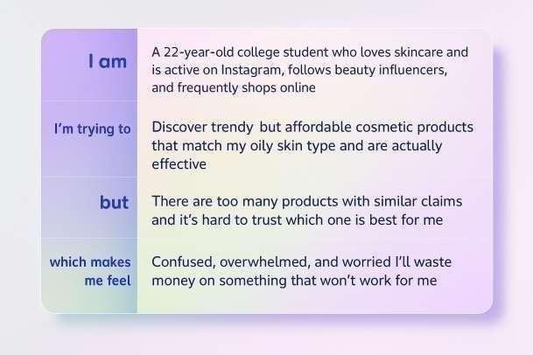

**Customer Problem Statement Template for Cosmetic Insights – Navigating Cosmetics Trends and Consumer Insights with Tableau:**

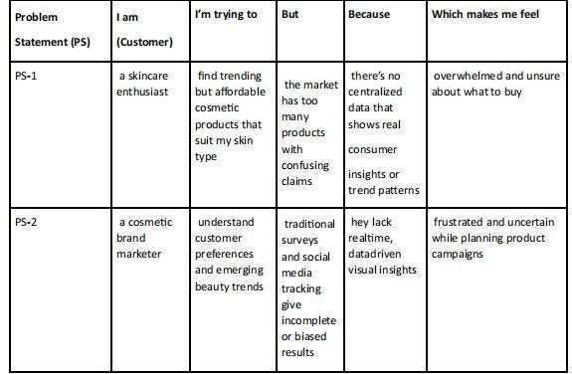

* 1. **Empathy Map Canvas**

An empathy map is a simple, easy-to-digest visual that captures knowledge about a user’s behaviours and attitudes.

It is a useful tool to helps teams better understand their users.

Creating an effective solution requires understanding the true problem and the person who is experiencing it. The exercise of creating the map helps participants consider things from the user’s perspective along with his or her goals and challenges.

**Example:- Cosmetic Insights – Navigating Cosmetics Trends and Consumer Insights with Tableau**

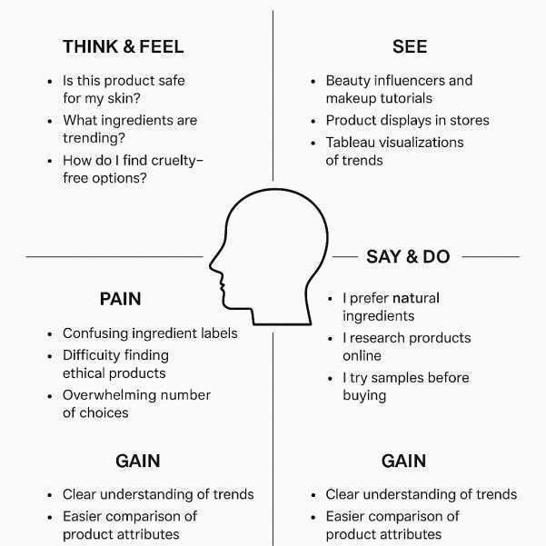

* 1. **Brainstorming**

**Problem:** Understanding how cosmetic brands and products perform across pricing, skin- type suitability, and popularity using Tableau visualizations. **Step 2:**

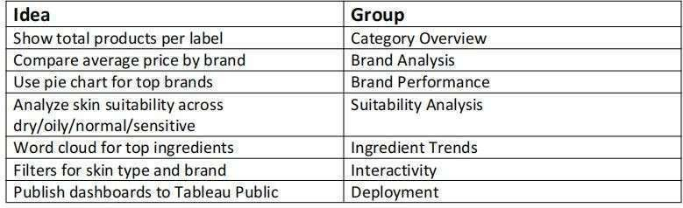**Brainstorming, Idea Listing and Grouping:**

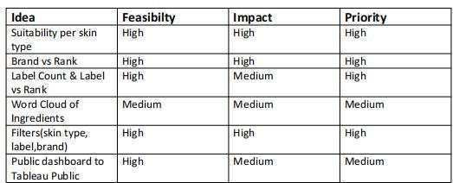**Step 3: Idea Prioritization:**

1. **REQUIREMENT ANALYSIS**
   1. 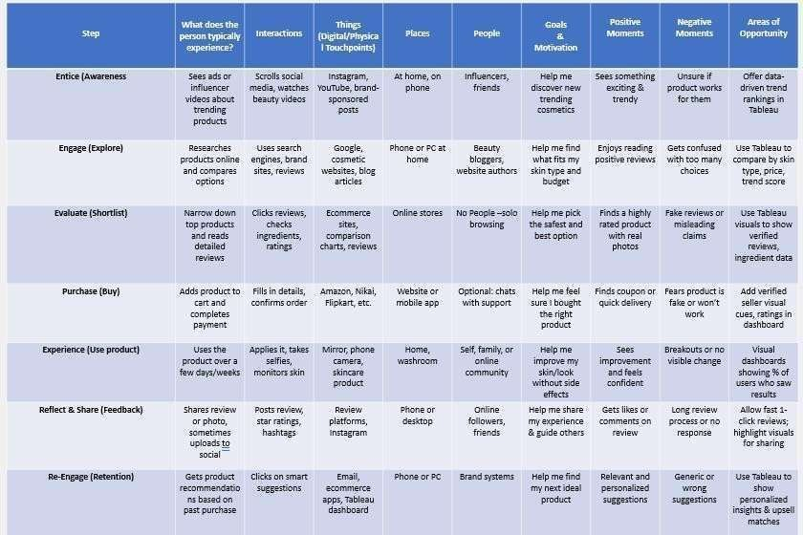**Customer Journey map**
   2. **Solution Requirement**

**Functional Requirements:**

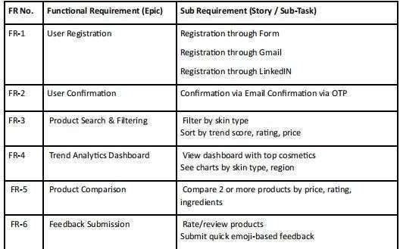Following are the functional requirements of the proposed solution

**Non-functional Requirements:-**

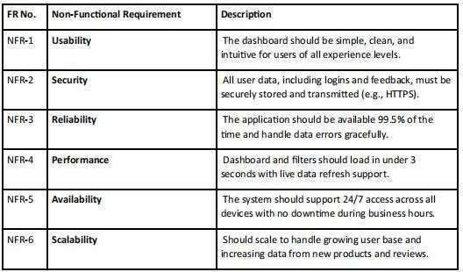Following are the non-functional requirements of the proposed solution

* 1. **Data Flow Diagram**

A Data Flow Diagram (DFD) is a traditional visual representation of the information flows within a system. A neat and clear DFD can depict the right amount of the system

requirement graphically. It shows how data enters and leaves the system, what changes the information, and where data is stored.

**Example:-DFD Diagram for Cosmetic Insights – Navigating Cosmetics Trends and Consumer Insights with Tableau:**

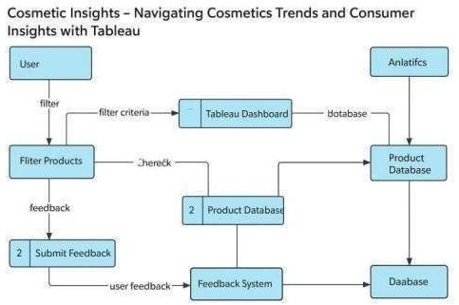

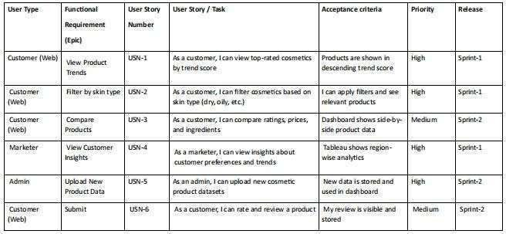**User Stories:**

* 1. **Technology Stack Technical**

**Architecture:**

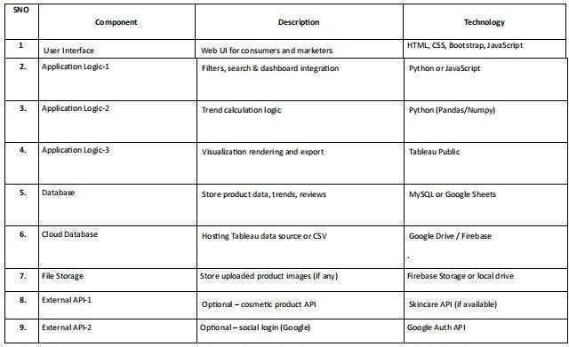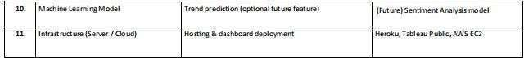

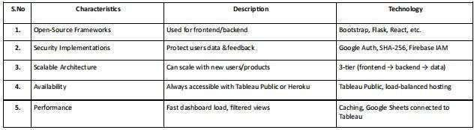**Application Characteristics:**

# PROJECT DESIGN

* 1. **Problem Solution Fit Template:-**

**Customer Segment**

Young adults (18–35), especially women, who are skincare-conscious and follow beauty trends online. They actively browse cosmetic sites, follow influencers, and buy based on peer reviews and trends.

**Problem Statement**

Users are overwhelmed by too many cosmetic product options, uncertain reviews, and no clear insight into what actually works for their skin type and budget. Marketers also struggle to understand real-time customer trends.

**Existing Alternatives**

They rely on Instagram influencers, YouTube reviews, brand blogs, and e-commerce reviews, which are often biased, scattered, and not data-backed.

**Your Solution**

An interactive Tableau dashboard that displays real-time cosmetic product trends, filters by skin type, budget, popularity, and allows users/marketers to visualize data-driven insights.

**Unique Value Proposition (UVP)**

First-of-its-kind visual analytics tool for cosmetics trends that helps consumers make informed choices and gives marketers real-time behavioral insights.

**Key Features / Functions**

* Product filtering by skin type, price, and region
* Popular product trends shown in graphs
* Compare ratings and reviews visually
* Customer feedback tracking
* Marketer insights dashboard

**User Benefits**

Users can confidently choose the right cosmetics, avoid misinformation, and save money. Marketers can design better campaigns using real data.

**Solution Validation**

Validated through problem statements, user stories, and dashboards built in Tableau

which showcase real-time filtering, review visualizations, and customer behavior tracking.

**Purpose:**

* Solve complex problems in a way that fits the state of your customers.
* Succeed faster and increase your solution adoption by tapping into existing mediums and channels of behavior.
* Sharpen your communication and marketing strategy with the right triggers and messaging.
* Increase touch-points with your company by finding the right problem-behavior fit and building trust by solving frequent annoyances, or urgent or costly problems.
* Understand the existing situation in order to improve it for your target group

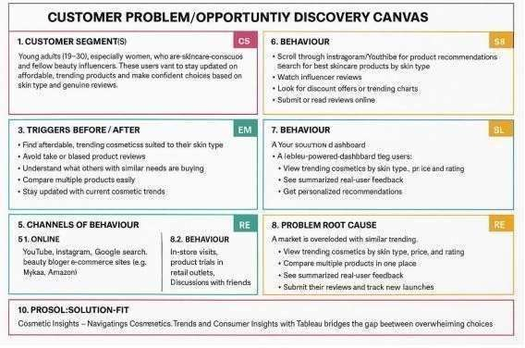**Template:**

* 1. **Proposed Solution Proposed Solution Template:**

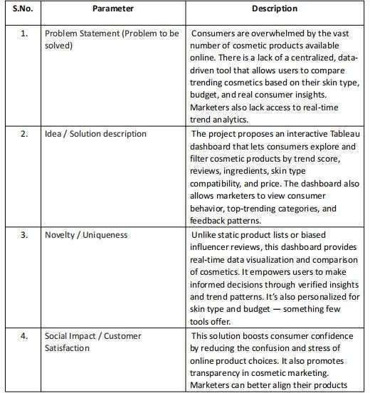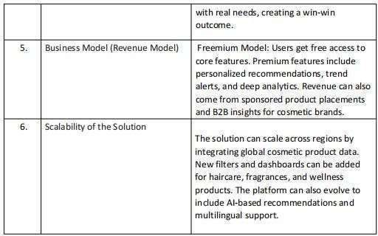

* 1. **Solution Architecture**

Solution architecture is a complex process – with many sub-processes – that bridges the gap between business problems and technology solutions. Its goals are to:

* + - Find the best tech solution to solve existing business problems.
    - Describe the structure, characteristics, behavior, and other aspects of the software to project stakeholders.
    - Define features, development phases, and solution requirements.
    - Provide specifications according to which the solution is defined, managed, and delivered.

**KEY ASPECTS OF YOUR SOLUTION ARCHITECTURE**

1. **User Layer (Entry Point)** o

Users include:

 Cosmetic consumers: use filters to discover products  Marketers: analyze trends and user behavior

* + Interact via a simple, responsive web interface with embedded Tableau dashboard

1. **User Interface (Frontend)** o Technologies:

HTML, CSS, Bootstrap, JavaScript o Features:

 Filters: skin type, budget, brand, rating

 Search and comparison interface

 Embedded Tableau dashboards for data visuals

1. **Application Layer (Backend)** o

Technologies: Python (Flask/Streamlit) or JavaScript (Node.js)o Functions:

 Pass user inputs (filters) to Tableau

 Handle login/auth (if used)

 Process and fetch data from review/product databases

 Optional: route feedback submission

1. **Visualization Layer**

**(Dashboard)** o Tool: Tableau Public or Tableau Server

* + Displays:

 Top trending cosmetic products

 Charts by skin type, rating, region, category

 Comparison visuals for price, review score, ingredients

1. **Data Sources** o Sources:

 Product Data: CSV / MySQL / Google Sheets  Review Data: Customer ratings & feedback o Features:

 Structured datasets allow filtering and charting

 Can be updated regularly or live connected

1. **Feedback Engine (Optional)** o

Collects product ratings/reviews from users o Stores in review repository o Feeds into Tableau to update user satisfaction visuals

1. **Hosting & Storage** o Tableau Public: for hosting dashboards o

GitHub Pages / Heroku: for web app or frontend o Google Drive / Firebase: for storing files and datasets

1. **Data Flow** o User → UI → Backend → Tableau → Visualization o Optionally, Feedback → Stored → Updates Dashboard
2. **Scalability** o Add more product datasets o Support multi-category expansion: skincare, makeup, fragrance o Add AI/ML trend prediction module in future
3. **Security (Optional/Advanced)**

* OAuth for secure login (Google, LinkedIn)
* Backend validation for data inputs and review authenticity

**Solution Architecture Diagram**

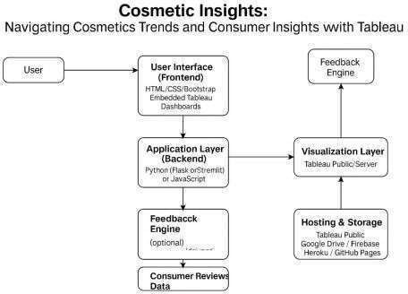

1. **PROJECT PLANNING & SCHEDULING**
   1. **Project Planning**

**Product Backlog, Sprint Schedule, and Estimation**

Use the below template to create product backlog and sprint schedule

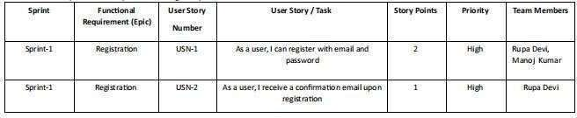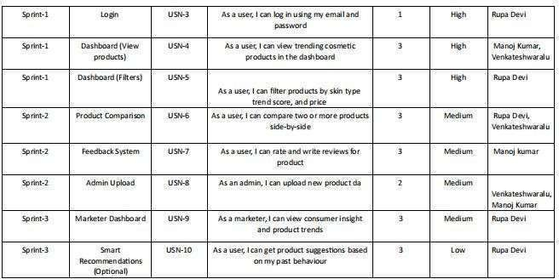

**Project Tracker, Velocity & Burndown Chart:- (4 Marks)**

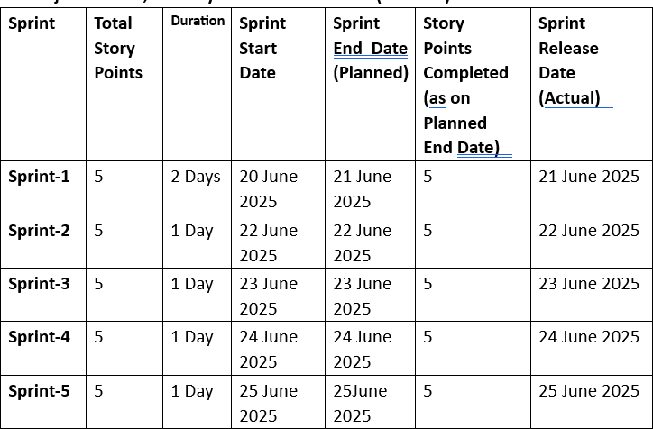

**Velocity:-**

**Average Velocity = 25 / 6 = 4.166... ≈ 4.2 story points/day**

**Burndown Chart:-**

A burn down chart is a graphical representation of work left to do versus time. It is often used in agile software development methodologies such as Scrum.

However, burn down charts can be applied to any project containing measurable progress over time

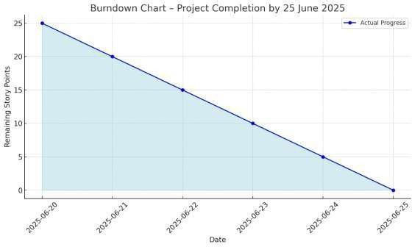

# FUNCTIONALAND PERFORMANCE TESTING:-

* 1. **Performance Testing Model Performance Testing:** -

Project team shall fill the following information in model performance testing template

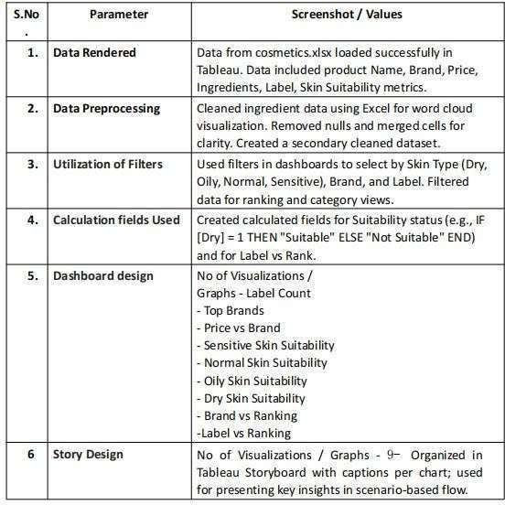

**Screenshots of Dashboard 1 with Filters :**

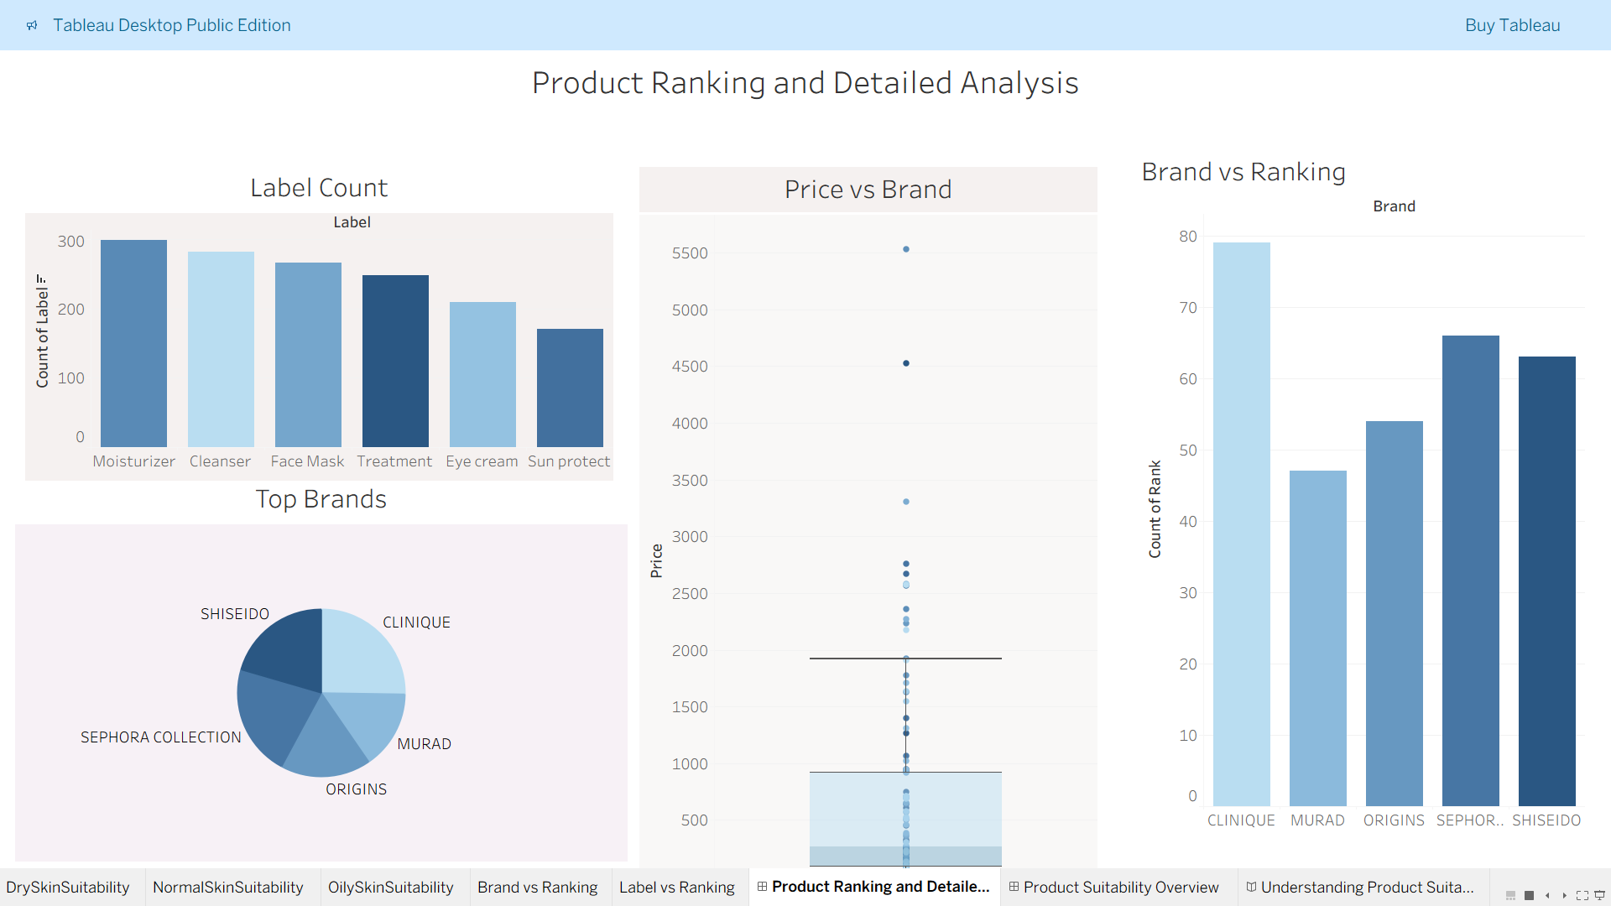

**Screenshot of Dashboard 2 with Filters:**

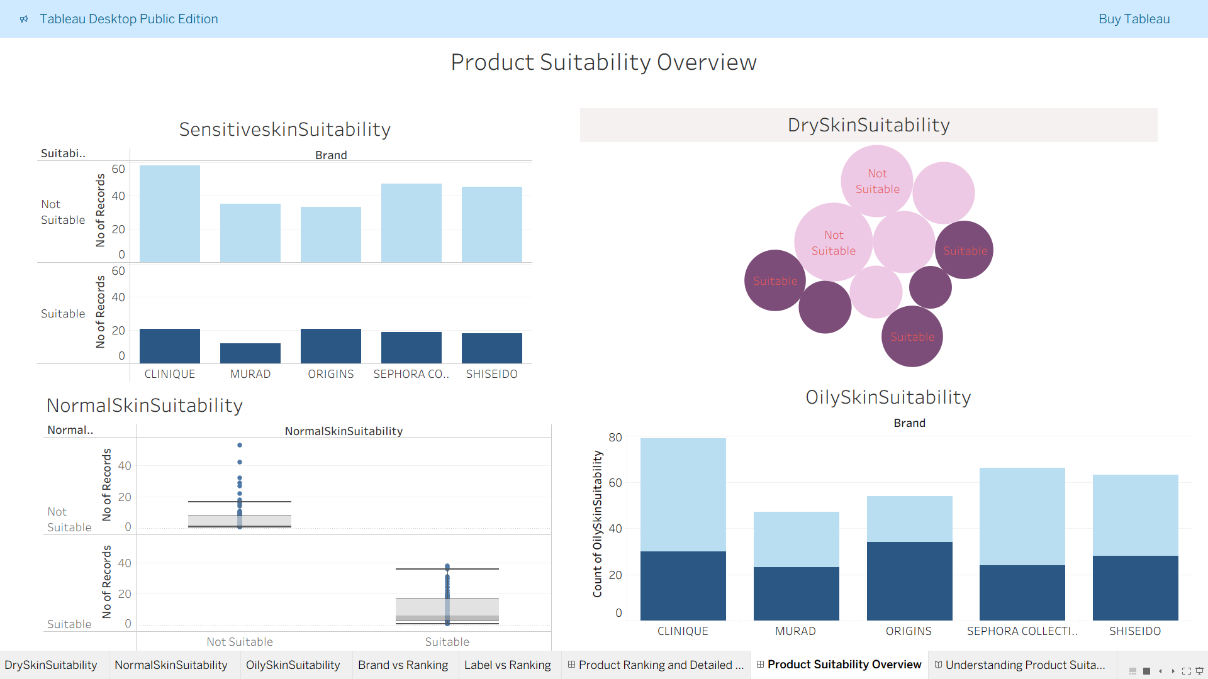

# RESULTS :

* 1. Output Screenshots Scenarios 1

and 3:

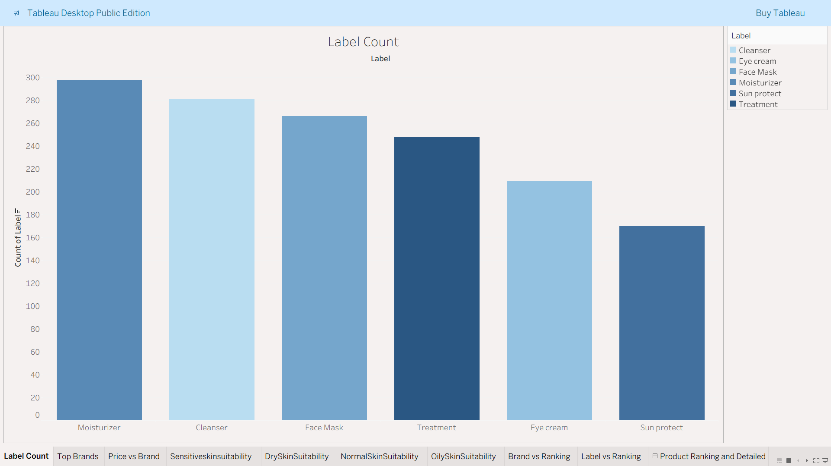

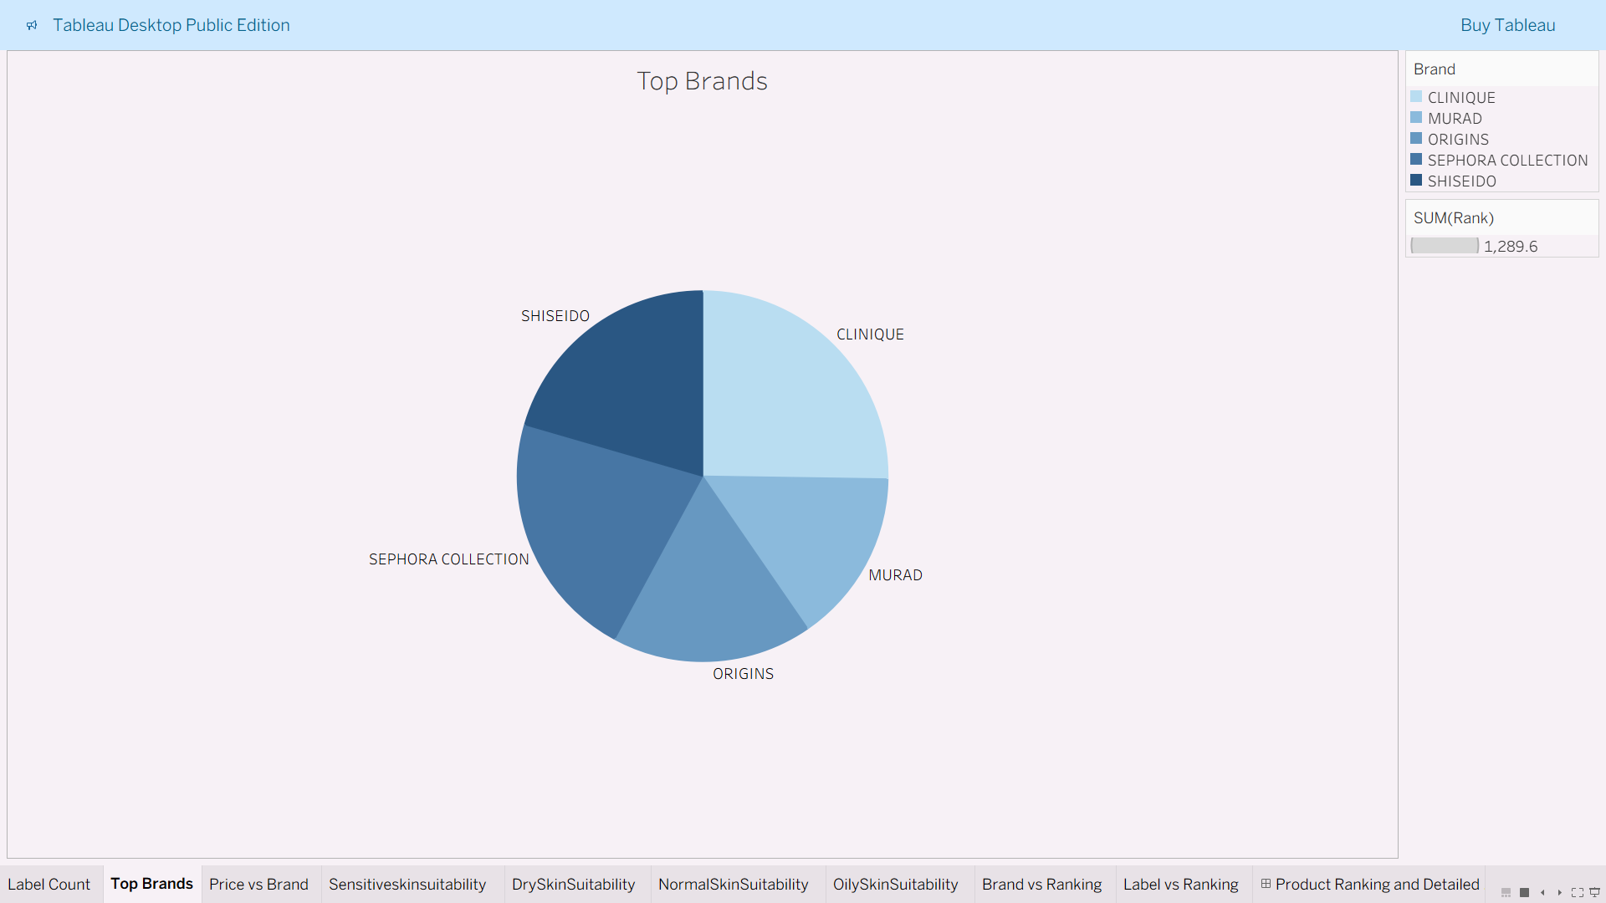

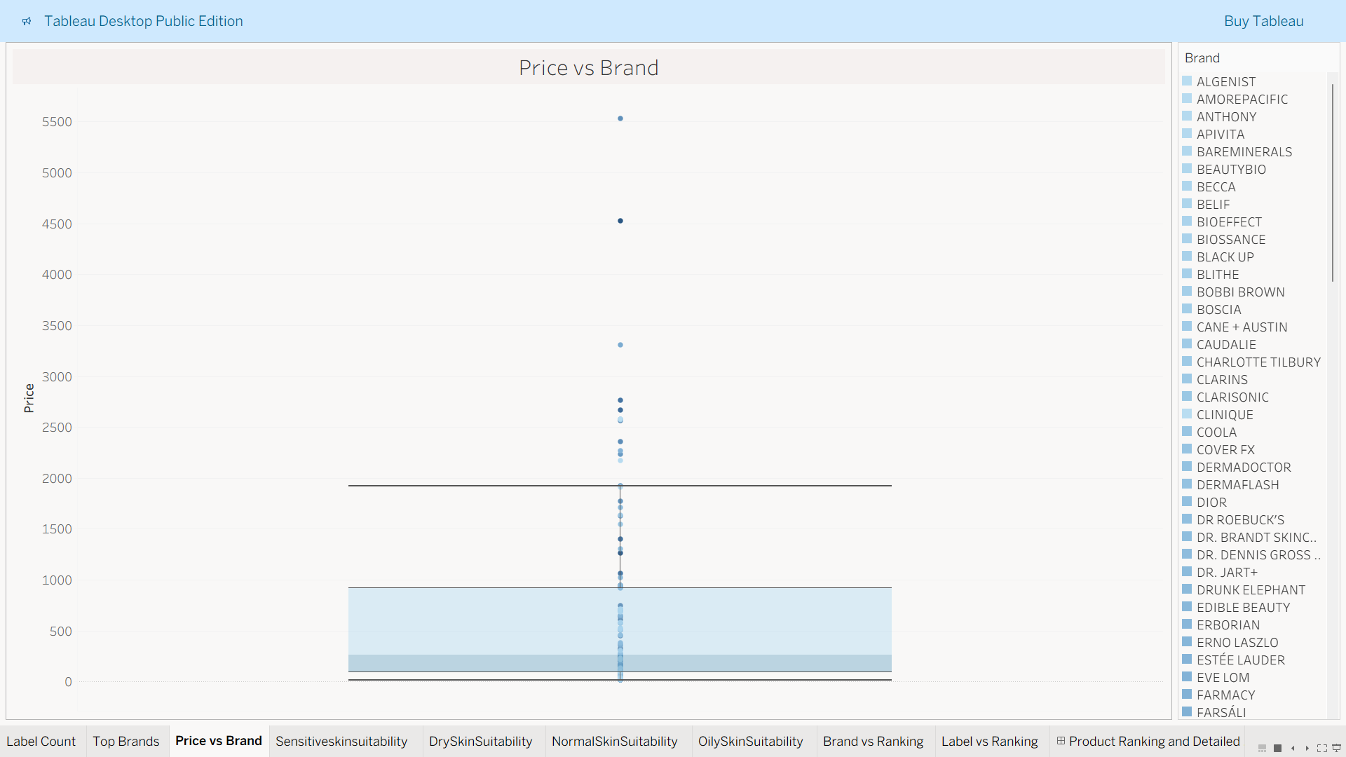

**Belongs to all scenarios1 , 2 and 3:**

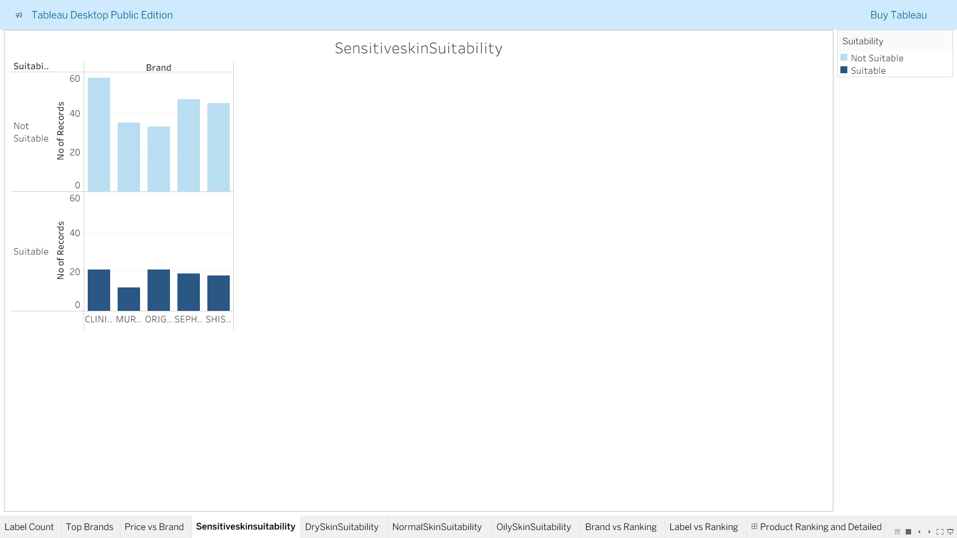

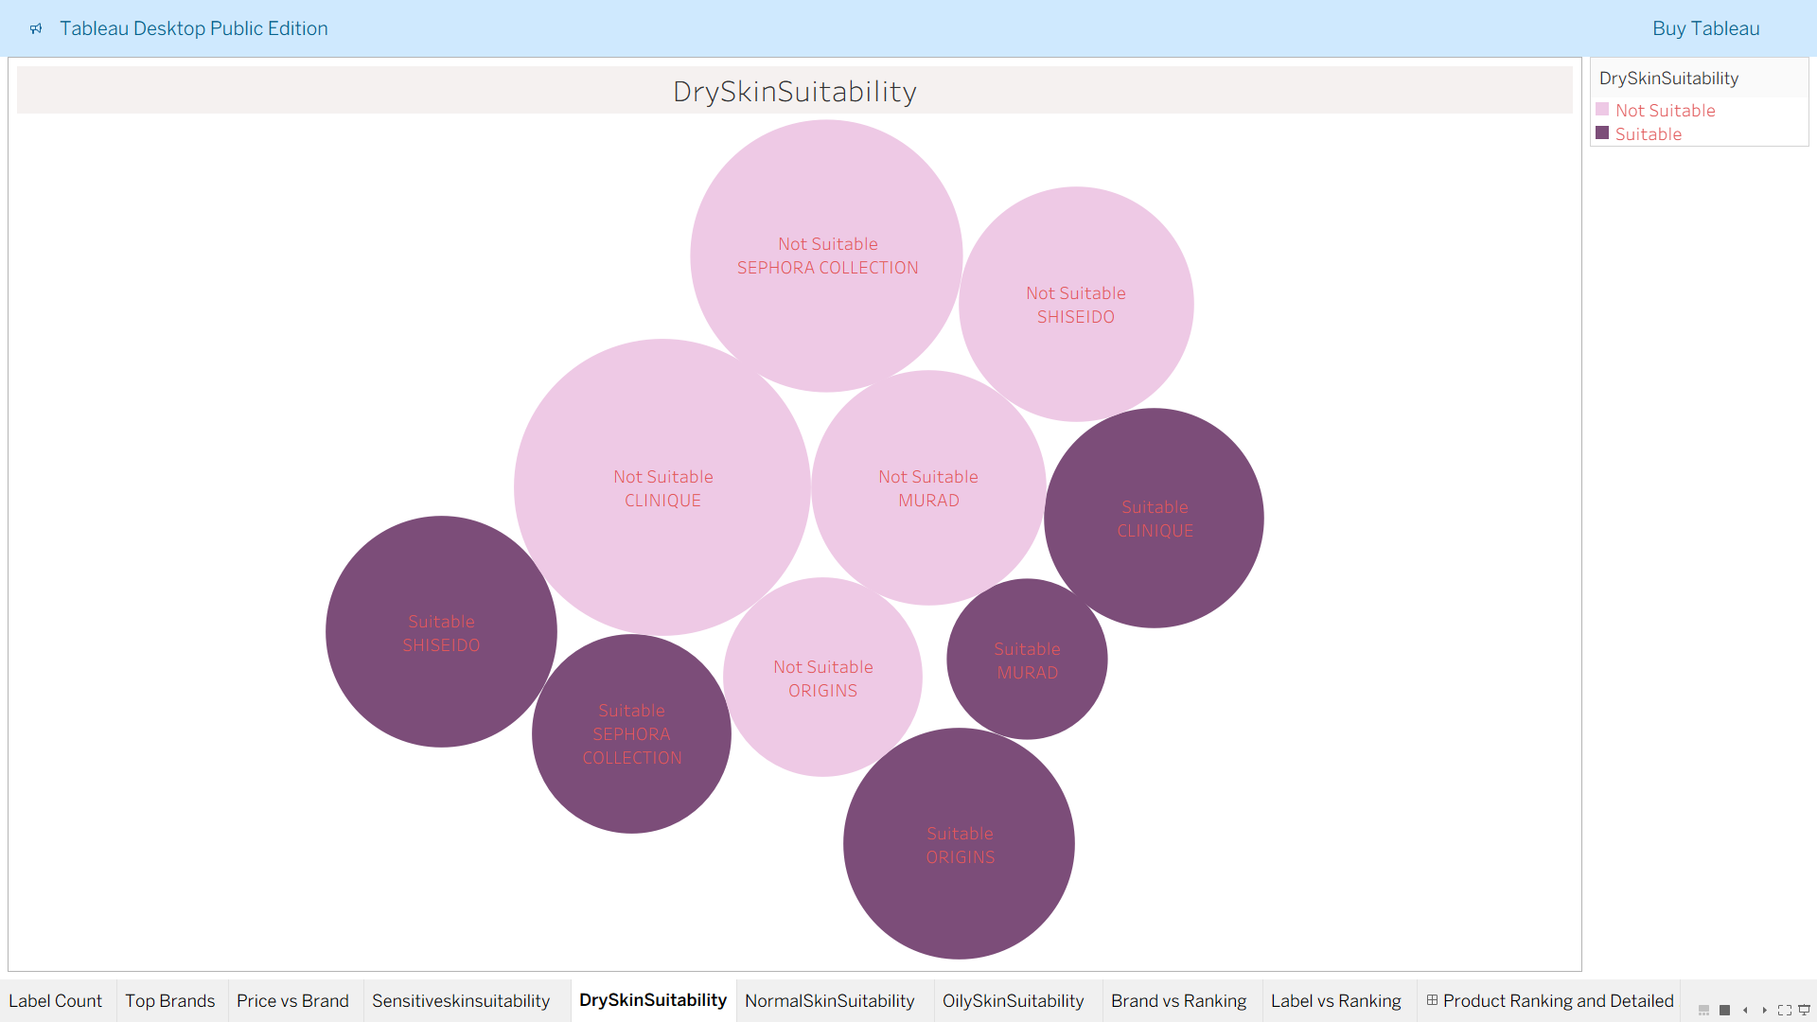

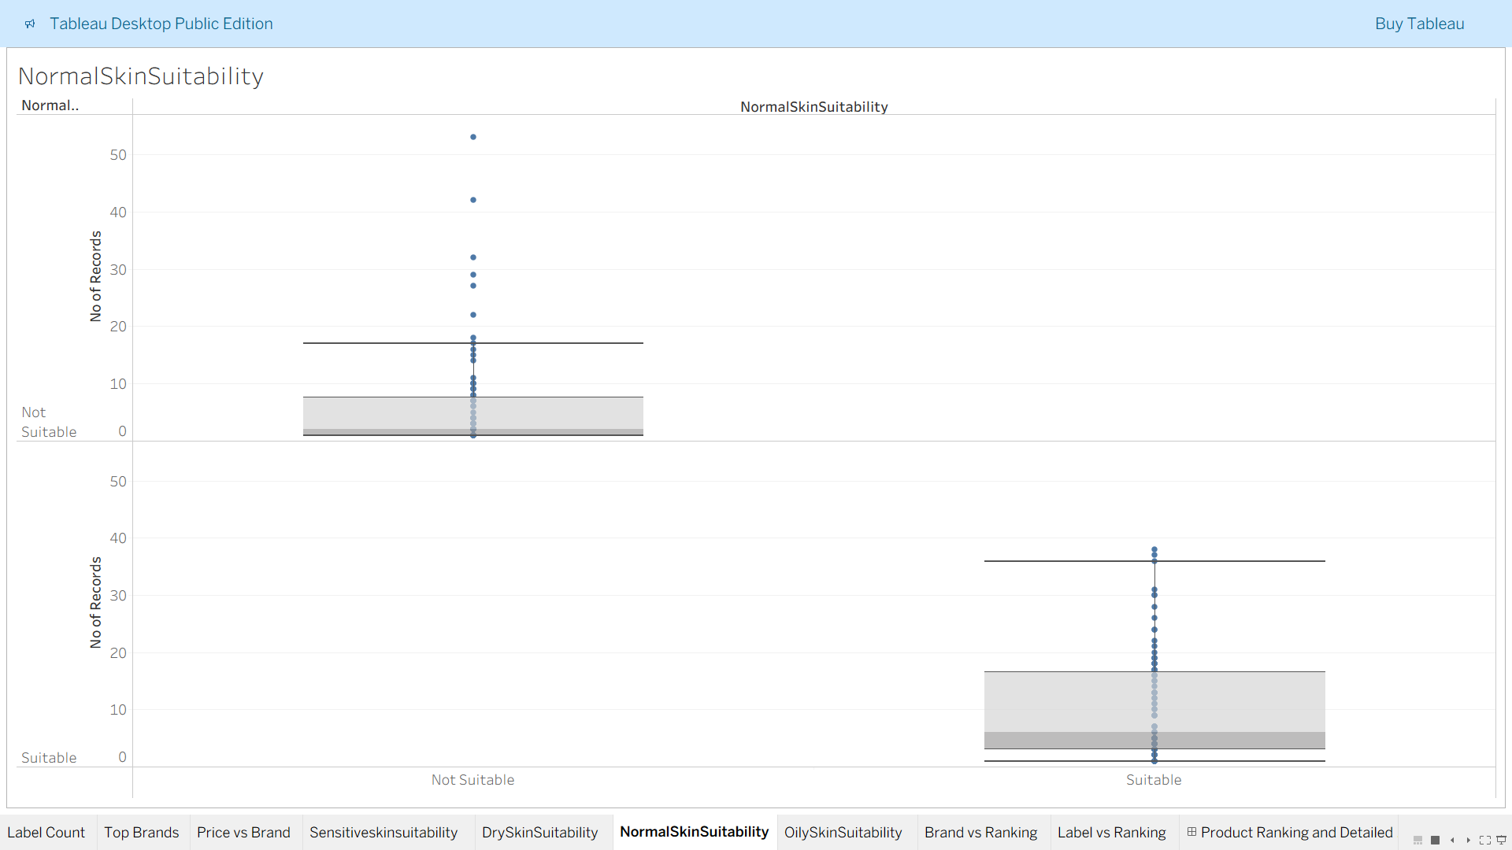

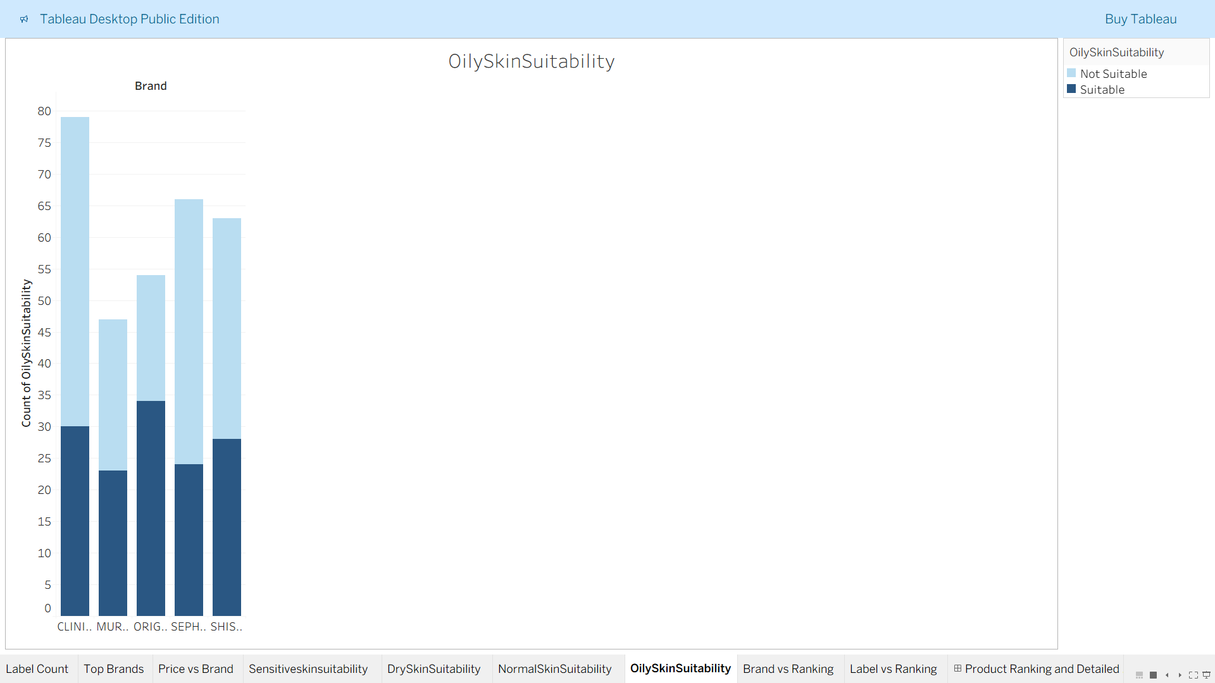

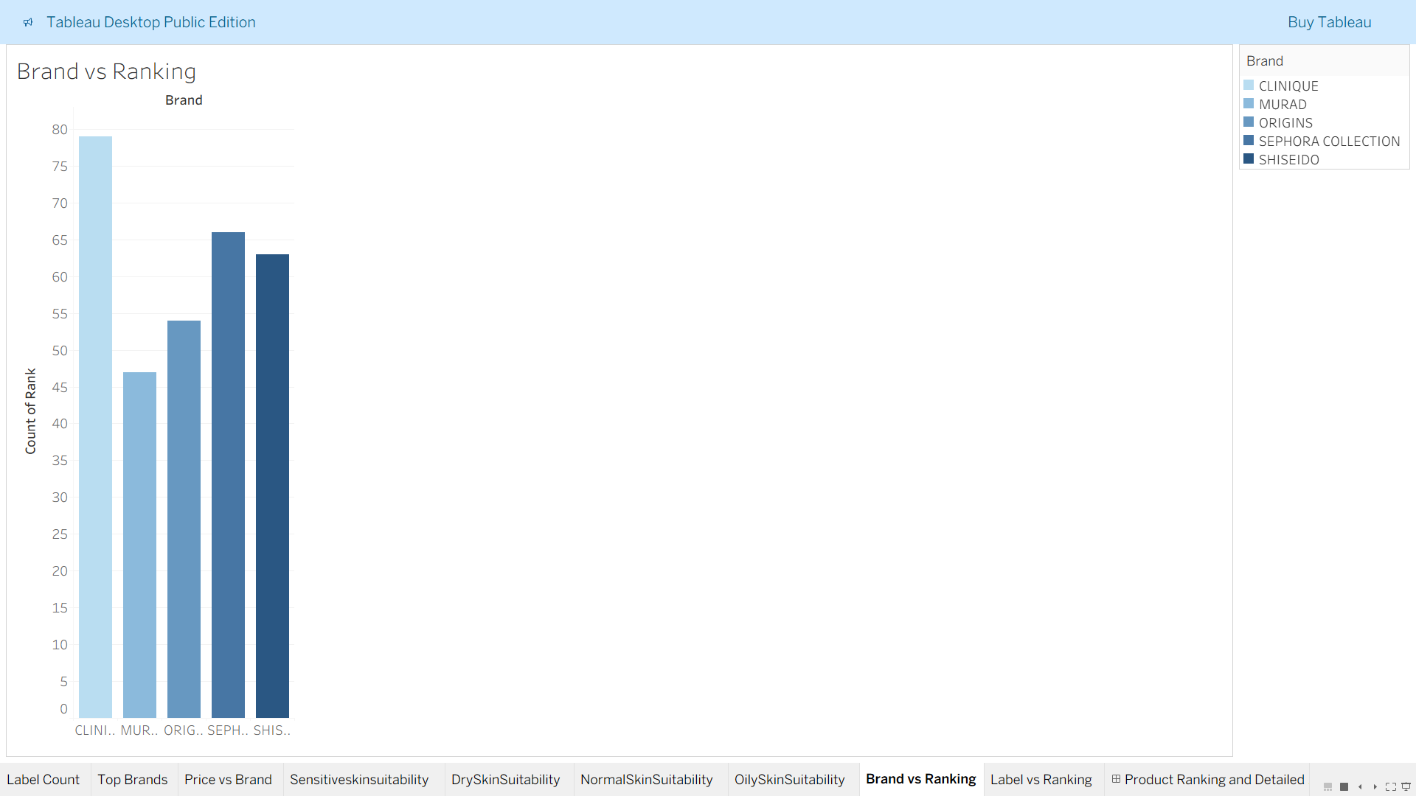

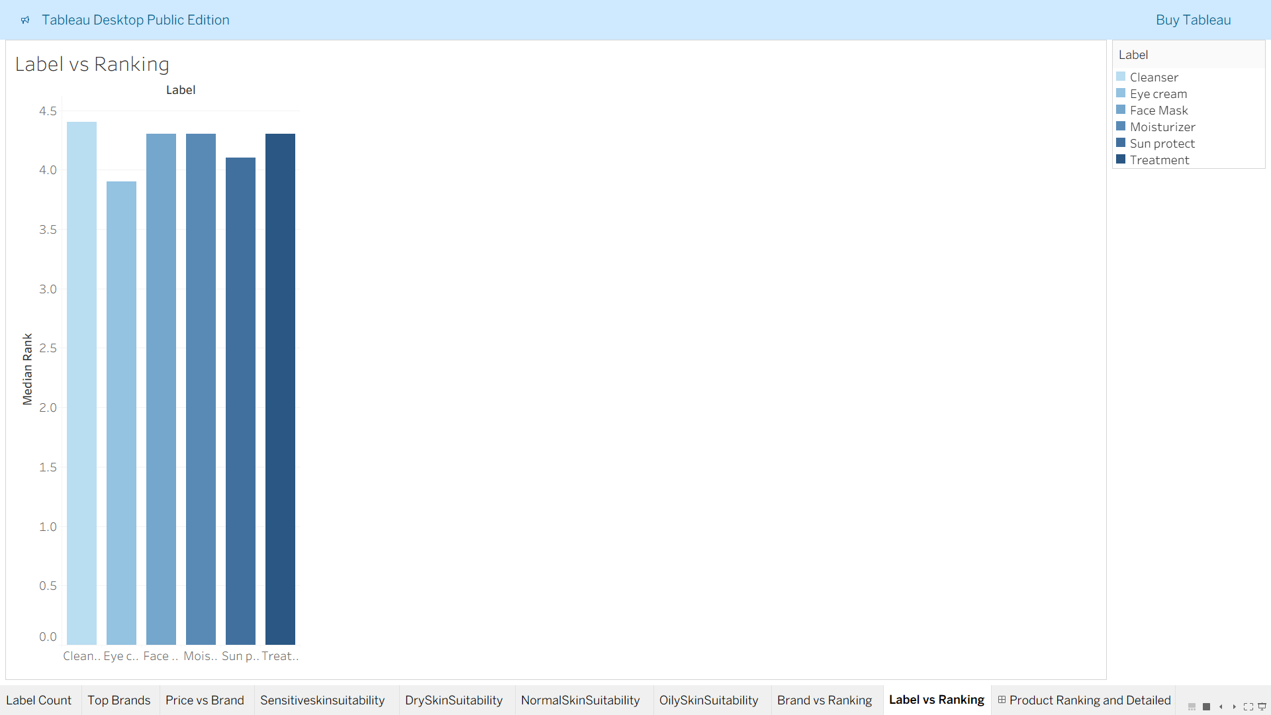

**Dashboard 1:**



**Dashboard 2:**



**Story 1:**

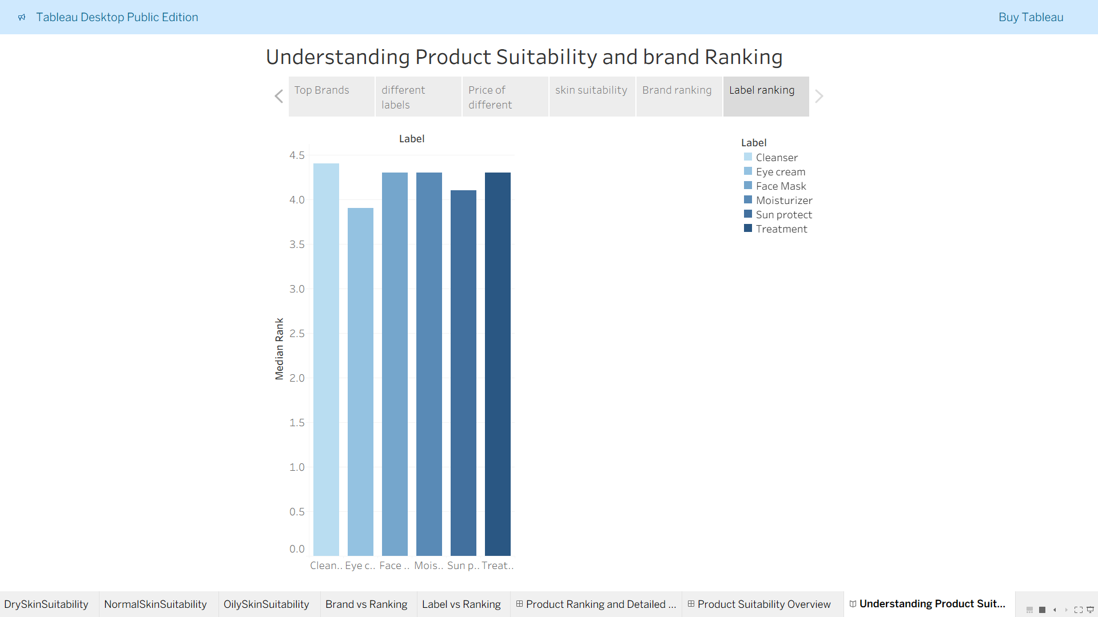

# ADVANTAGES & DISADVANTAGES:-

**Advantages:-**

1. **Interactive Dashboards**

Users can filter data by brand, skin type, label, and more to view personalized insights in real time.

1. **Data-Driven Decision Making**

Helps cosmetic companies understand consumer preferences, product trends, and brand performance to make informed marketing and R&D decisions.

1. **Visual Clarity**

Tableau’s clean and dynamic visuals make complex data easier to understand for both technical and non-technical users.

1. Skin-Type Suitability Analysis

Offers specific insights for users with dry, oily, normal, or sensitive skin — a valuable differentiator for product targeting.

1. **Ingredient Trend Discovery**

The Word Cloud reveals commonly used ingredients, helping users track popular or overused components.

1. **Scalable Visualization**

The system can be expanded with new data (sales, reviews, etc.) for deeper future analysis.

**Disadvantages:-**

1. **Static Dataset**

Since the data used is not real-time or continuously updated, insights may become outdated over time.

1. **Manual Preprocessing Needed**

The ingredients column required cleaning and restructuring outside Tableau (in Excel), which adds effort and dependency.

1. **Limited Predictive Capabilities**

This version focuses on visual reporting; it doesn't yet include machine learning or trend forecasting.

1. **Tool Dependency**

Requires Tableau software (or Tableau Public) for viewing and interaction — which may not be accessible to all users.

1. **No User Feedback Loop**

Currently lacks a direct mechanism to collect feedback or validate insights with real consumer responses.

1. **CONCLUSION** : -

The project “Cosmetic Insights – Navigating Cosmetics Trends and Consumer Insights with Tableau” successfully demonstrates the power of data visualization in the beauty industry. By leveraging Tableau, we transformed a static cosmetic product dataset into meaningful and interactive dashboards that highlight product distribution, brand

performance, pricing strategies, ingredient usage, and skin-type suitability.

The visualizations not only simplify complex data but also support evidence-based decision-making for brands, marketers, and consumers. From ingredient trends to

suitability scores for different skin types, the dashboards provide a complete view of cosmetic product behavior and market dynamics.

Overall, the project meets its goals of making data accessible, insightful, and actionable through effective visual storytelling.

# FUTURE SCOPE:-

1. **Integration of Real-Time Data**

The dashboard can be enhanced by connecting to live data sources such as sales databases, e-commerce APIs, or review platforms for continuous updates.

1. **Sentiment Analysis from Customer Reviews**

By incorporating text analytics or NLP, the project can analyze consumer sentiment from online product reviews to better understand user satisfaction and concerns.

1. **Recommendation Engine**

Using user preferences and suitability scores, the system can be extended to recommend the most appropriate products for different skin types or concerns.

1. **Mobile and Web Embedding**

The dashboards can be embedded into brand websites or mobile apps, providing real-time insights to both internal teams and customers.

1. **Advanced Predictive Analytics**

Machine learning models can be added to predict emerging trends, ingredient effectiveness, or customer demand across categories and regions.

1. **User Feedback Integration**

Enabling feedback capture directly within dashboards would improve insight validation and help refine product development strategies.

1. **Geographic Analysis**

By including location-based data, brands can visualize regional trends and optimize marketing or stocking strategies accordingly.

# APPENDIX:-

* **Dataset Link :** https://[www.kaggle.com/datasets/kingabzpro/cosmetics-datasets](http://www.kaggle.com/datasets/kingabzpro/cosmetics-datasets)
* **GitHub & Project Demo Link :**

**GitHub Link:-**

<https://github.com/Yamini-2812/Cosmetic-Insights-Navigating-Cosmetics-Trends-and-Consumer-Insights-with-Tableau>

**Project Video Demo:**

